EXPERIMENT – 3

Create a simple cloud software application for Property Buying &amp; Rental process (In Chennai city) using any Cloud Service Provider to demonstrate SaaS.

Procedure:
Step 1: Goto Zoho.Com
Step 2: Login To the Zoho.Com
Step 3: Select One Application
Step 4: Enter Application Name
Step 5: Created New Application
Step 6: Select One Form
Step 7: The Software Hase Been Created.

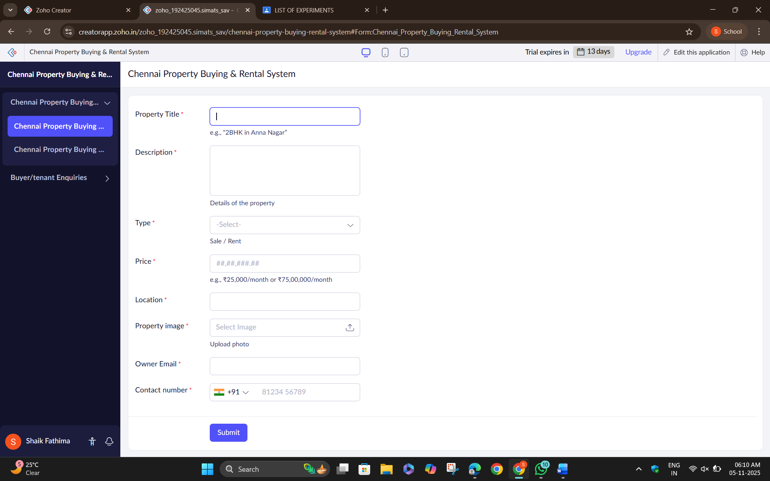

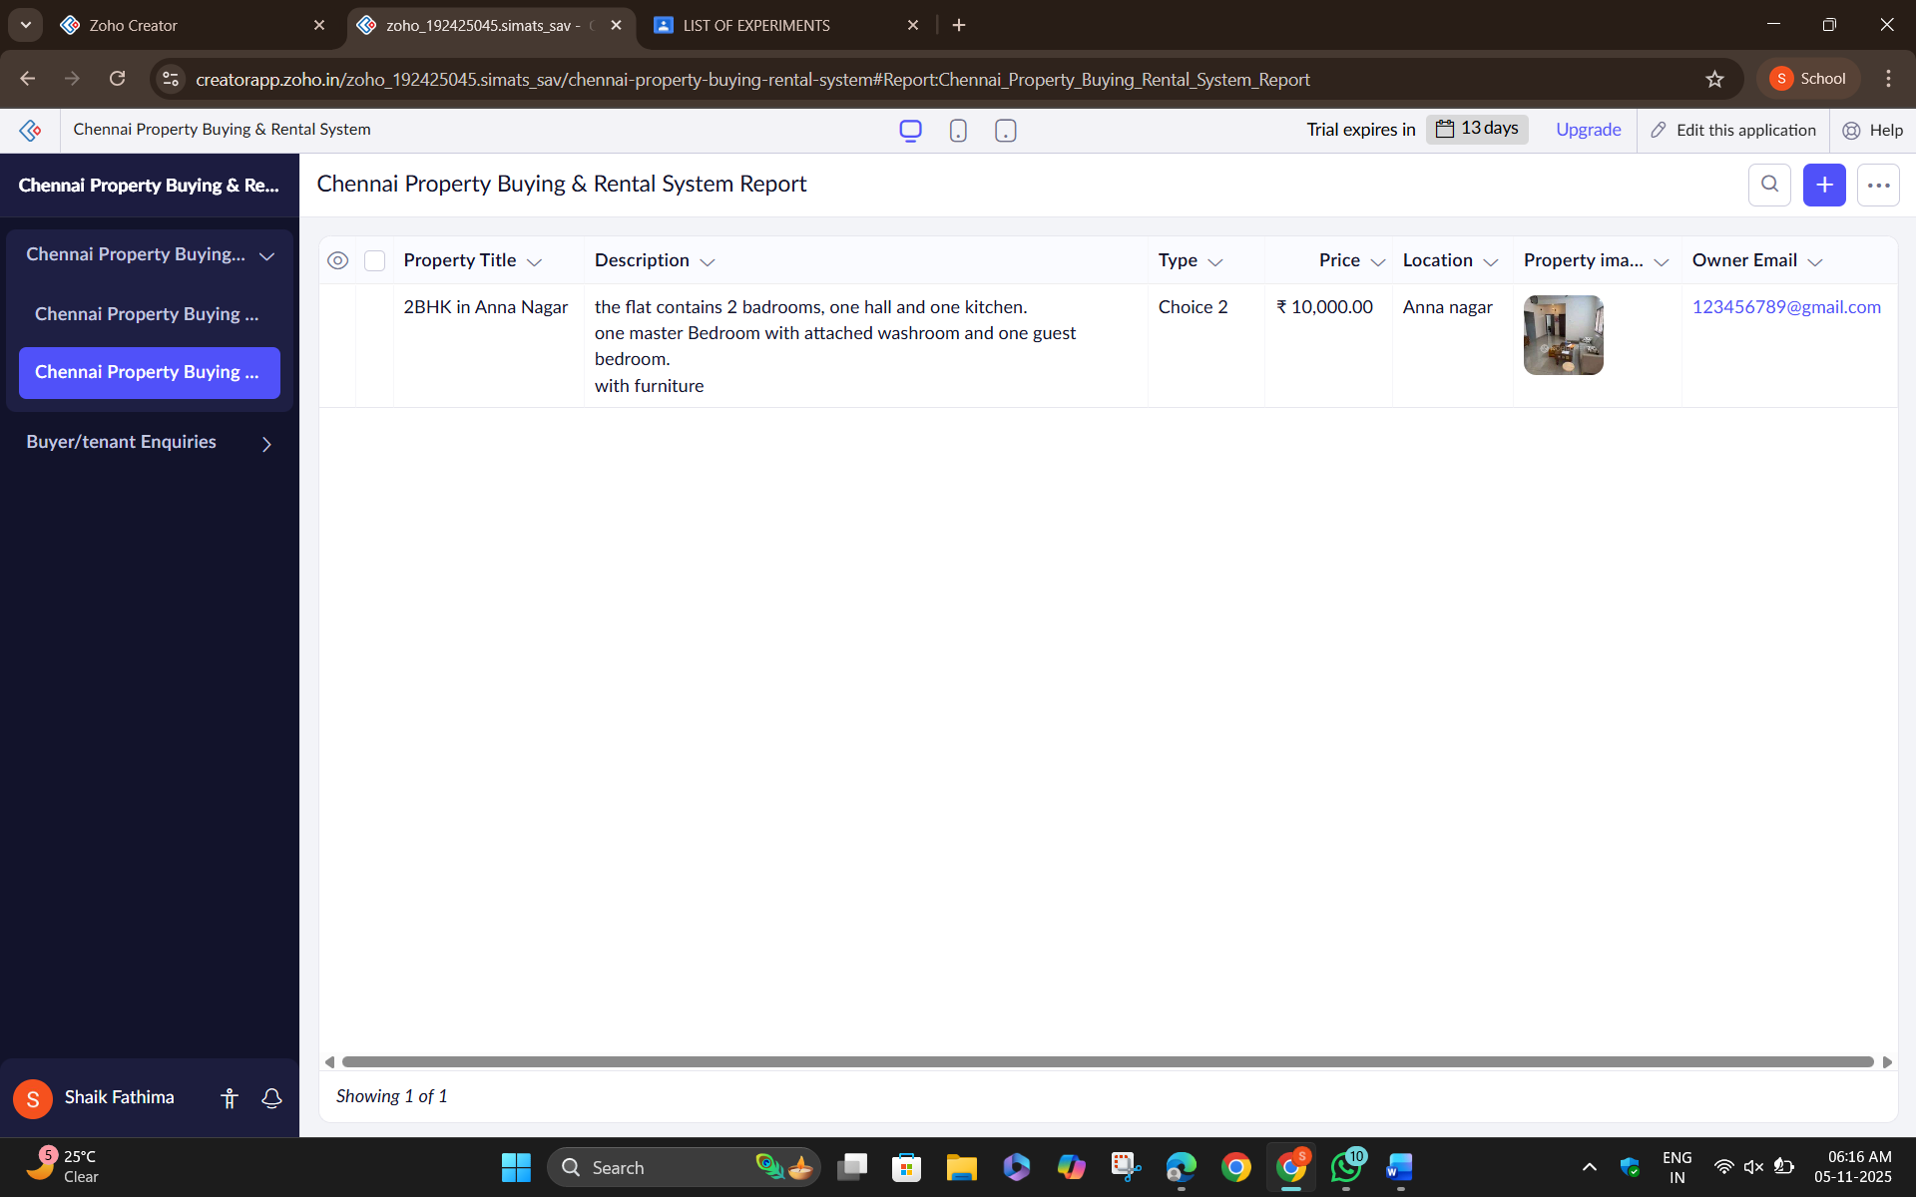

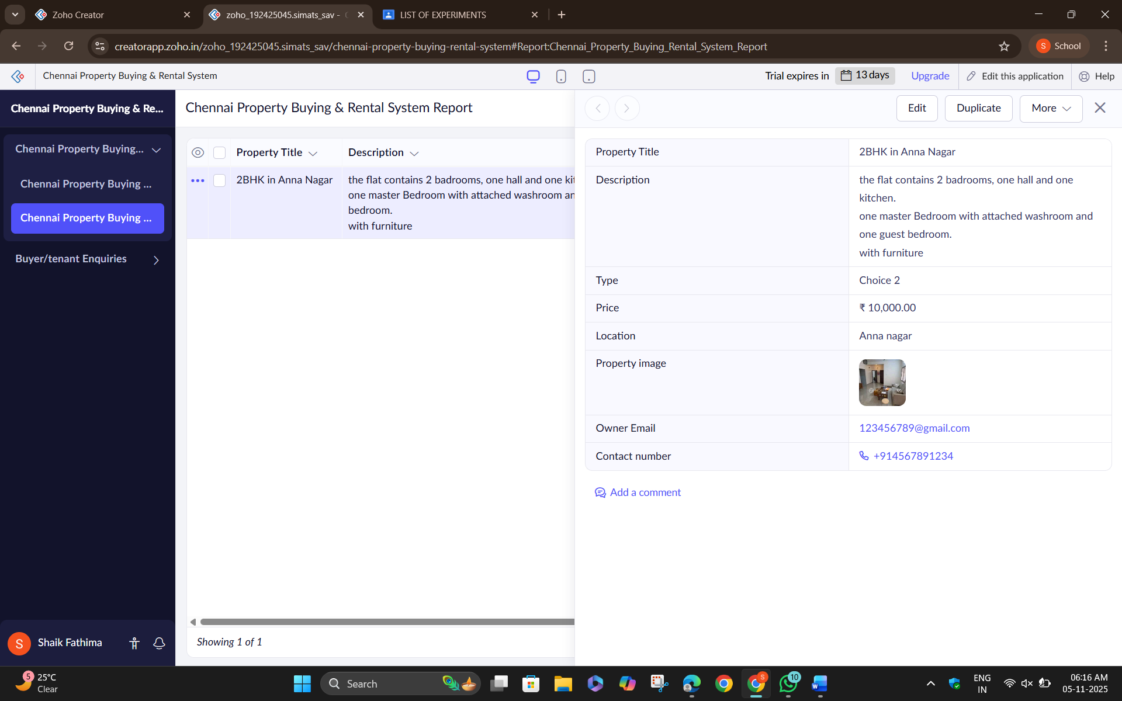

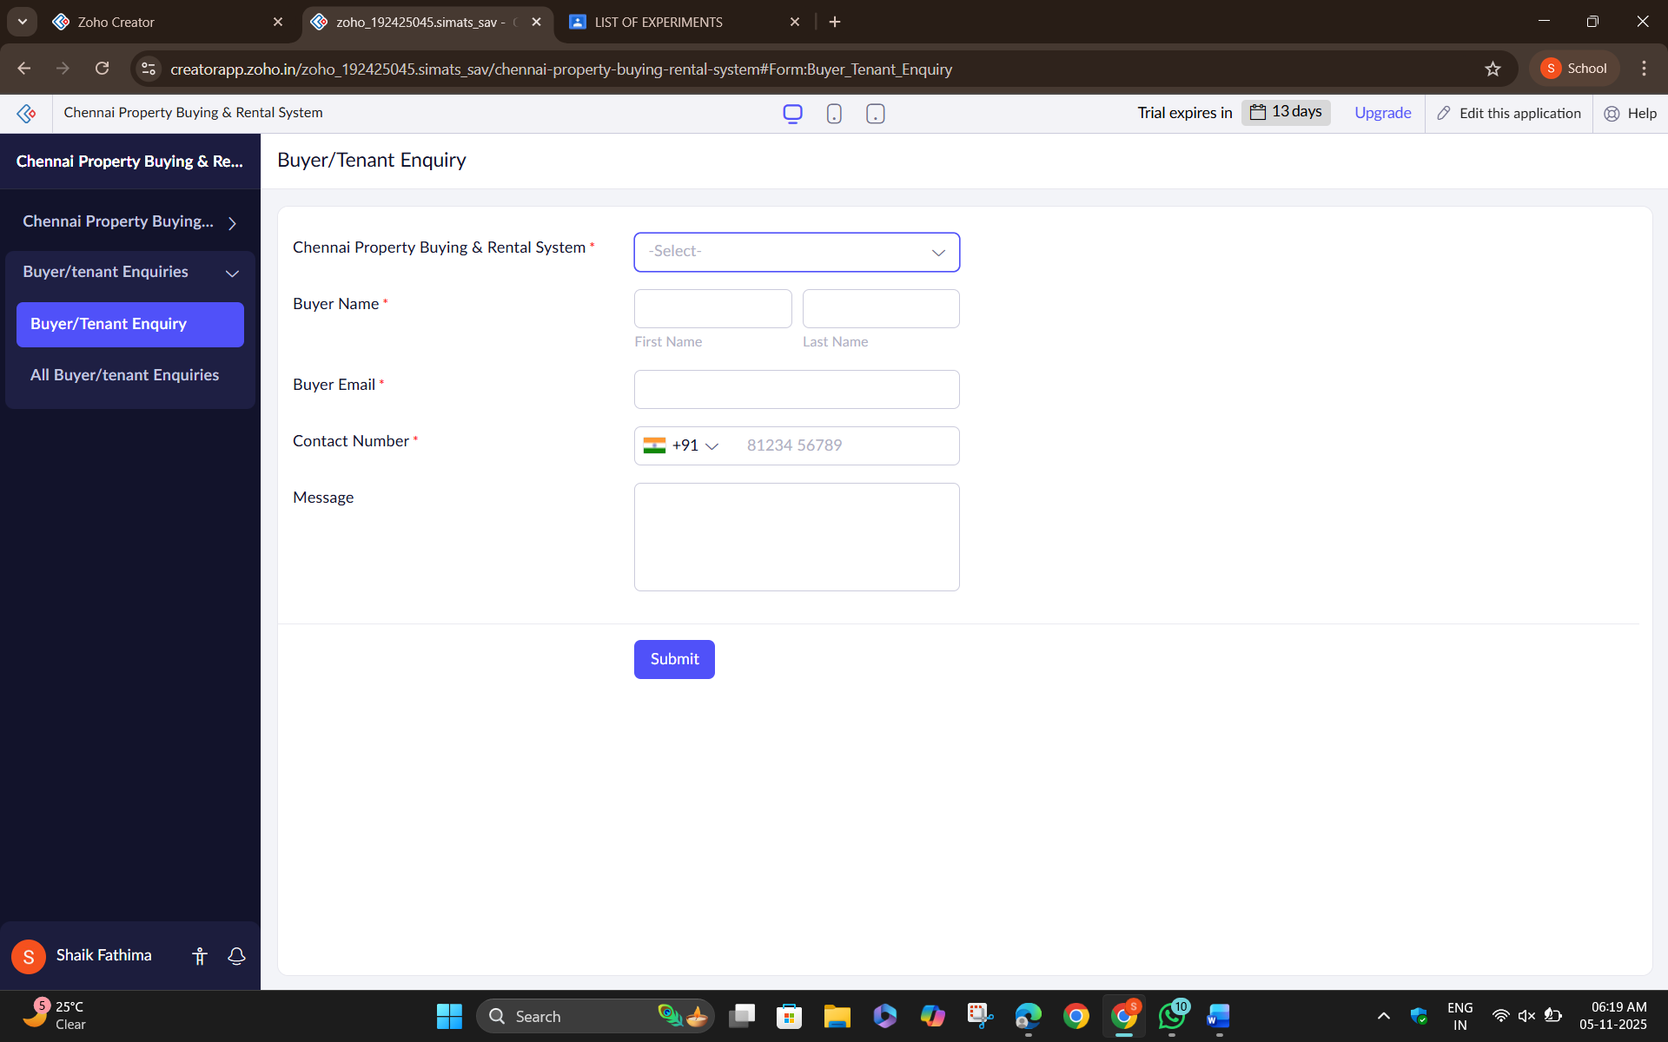

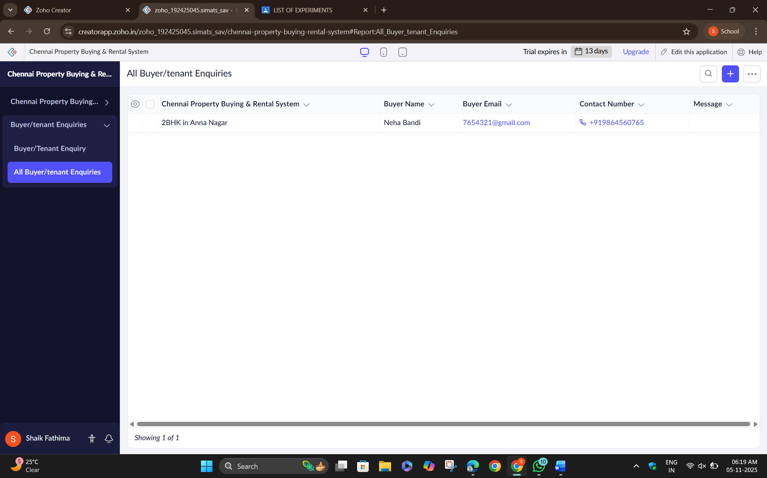

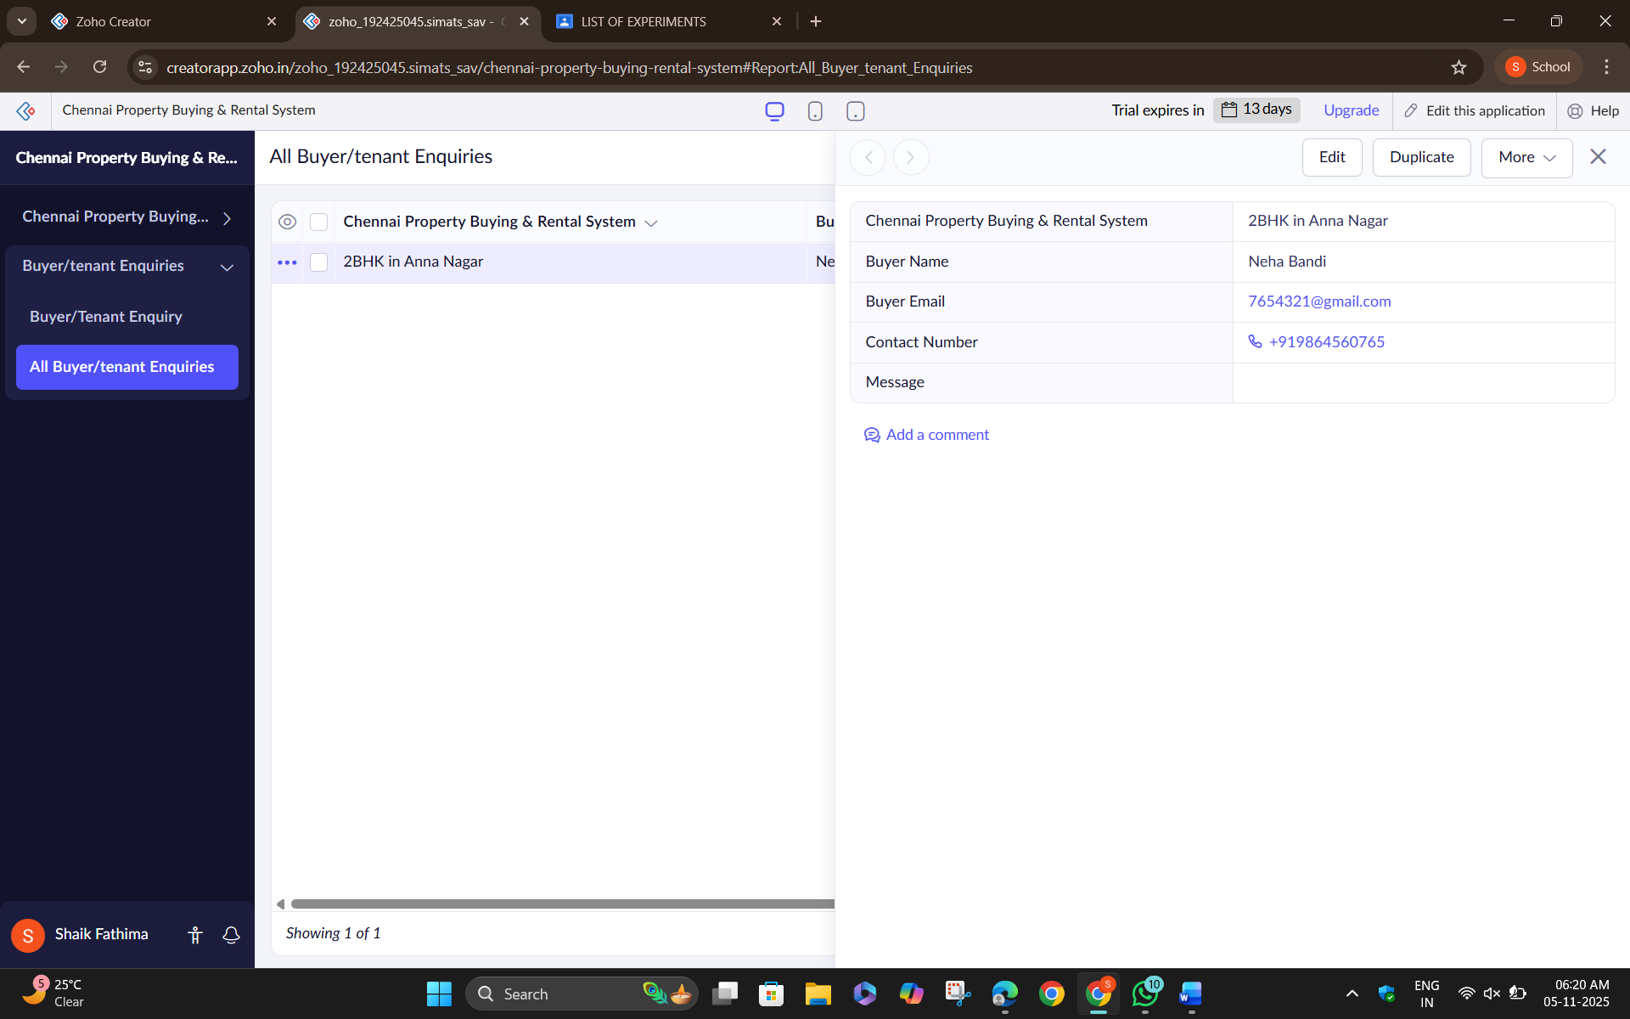

Result: Thus, the Property Buying &amp; Rental process (In Chennai city) is implemented using Zoho Software.

